# | Business Question | Purpose / Decision Driver
1 | Which products generate the highest revenue and profit across all stores? | Identify top performers for marketing and replenishment priorities.
2 | Which stores have the strongest and weakest sales performance over time? | Guide regional sales strategy and inventory distribution.
3 | How do sales trends vary by month, quarter, and year? | Detect seasonality and optimize promotions or staffing.
4 | What is the correlation between promotions (promo_type_1 / promo_type_2) and sales uplift? | Evaluate marketing ROI and refine promotion design.
5 | Which product clusters (from product hierarchy) show consistent growth or decline? | Understand long-term product line performance.
6 | How does stock level relate to sales performance (overstocking or stockouts)? | Improve demand forecasting and supply chain planning.
7 | Which cities or store types (storetype_id) drive the most revenue per square meter (store_size)? | Evaluate store efficiency and expansion opportunities.
8 | What’s the sales-to-stock ratio per product category or cluster? | Optimize inventory allocation.
9 | How do promotions differ in effectiveness across cities or clusters? | Localize campaign strategies.
10 | What are the most profitable product lines by hierarchy level (e.g., hierarchy3_id or hierarchy4_id)? | Support product development and portfolio decisions.

Send sales data to sql server in chunks for memory efficiency
In cmd we use the below command
- bcp retail_sales.dbo.fact_sales in "C:\Users\pc\Data analysis projects\retail sales analysis\fact_sales.csv" -S localhost\SQLEXPRESS -T -c -t "," -r "\n" -F 2

Preparing star schema in ms sql server
- Ensuring that all key columns have the same type
ALTER TABLE fact_sales ALTER COLUMN product_id VARCHAR(20) NOT NULL;
ALTER TABLE fact_sales ALTER COLUMN store_id VARCHAR(20) NOT NULL;
ALTER TABLE fact_sales ALTER COLUMN date DATE NOT NULL;
ALTER TABLE dim_date ALTER COLUMN date DATE NOT NULL;

ALTER TABLE dim_product ALTER COLUMN product_id VARCHAR(20) NOT NULL;
ALTER TABLE dim_store ALTER COLUMN store_id VARCHAR(20) NOT NULL;
- Set primary keys
ALTER TABLE dim_product
ADD CONSTRAINT PK_dim_product PRIMARY KEY (product_id);

ALTER TABLE dim_store
ADD CONSTRAINT PK_dim_store PRIMARY KEY (store_id);

ALTER TABLE dim_date
ADD CONSTRAINT PK_dim_date PRIMARY KEY (date);
- Add foreign keys [relationships]
ALTER TABLE fact_sales
ADD CONSTRAINT FK_fact_product
FOREIGN KEY (product_id)
REFERENCES dim_product(product_id);

ALTER TABLE fact_sales
ADD CONSTRAINT FK_fact_store
FOREIGN KEY (store_id)
REFERENCES dim_store(store_id);

ALTER TABLE fact_sales
ADD CONSTRAINT FK_fact_date
FOREIGN KEY ([date])
REFERENCES dim_date([date]);
- Add indexes for query speed
CREATE INDEX idx_fact_product ON fact_sales(product_id);
CREATE INDEX idx_fact_store ON fact_sales(store_id);
CREATE INDEX idx_fact_date ON fact_sales(date);

Answering the business questions
- Which products generate the highest revenue and profit across all stores?
To generate the highest 10 products in revenue and profit
We assumed that we have 30 % profit margin in our business and chose hirerachy3 in product dimension to balance the level of details of our required report in the below query

SELECT top 10
dp.hierarchy3_id,
SUM(fs.revenue) AS total_revenue,
SUM(fs.revenue * 0.30) AS estimated_profit
FROM fact_sales fs
JOIN dim_product dp ON fs.product_id = dp.product_id
GROUP BY dp.hierarchy3_id

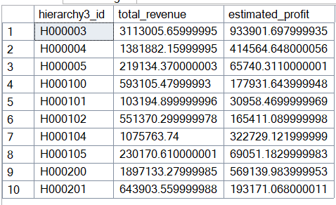
- Which stores have the strongest and weakest sales performance over time?
Here we decided to show the top and bottom 5 stores in revenue
SELECT top 5
fs.store_id,
ds.storetype_id,
SUM(fs.sales) AS total_units_sold,
SUM(fs.revenue) AS total_revenue
FROM fact_sales fs
JOIN dim_store ds ON fs.store_id = ds.store_id
GROUP BY fs.store_id, ds.storetype_id
ORDER BY total_revenue DESC;

Top 5 stores
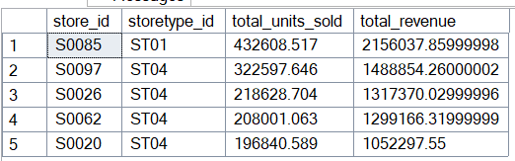
SELECT top 5
fs.store_id,
ds.storetype_id,
SUM(fs.sales) AS total_units_sold,
SUM(fs.revenue) AS total_revenue
FROM fact_sales fs
JOIN dim_store ds ON fs.store_id = ds.store_id
GROUP BY fs.store_id, ds.storetype_id
ORDER BY total_revenue asc;

Bottom 5 stores
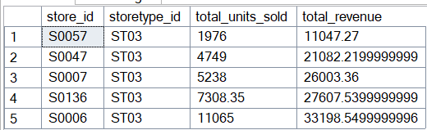
- How do sales trends vary by month, quarter, and year?
select
dd.year as year,
dd.quarter as Quarter,
dd.month as month,
sum(fs.sales) as units_sold,
sum(fs.revenue) as total_revenue
from fact_sales fs
join dim_date dd on fs.date = dd.date
group by dd.year, dd.quarter, dd.month
order by dd.year, dd.month

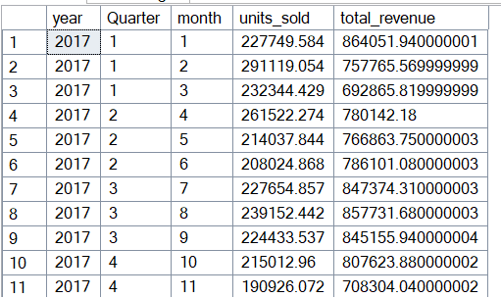

- What is the correlation between promotions (promo_type_1 / promo_type_2) and sales uplift?
SELECT
fs.product_id as product,
fs.sales as units_sold,

CASE WHEN fs.promo_type_1 IS NULL THEN 0 ELSE 1 END AS promo1_active,
CASE WHEN fs.promo_type_2 IS NULL THEN 0 ELSE 1 END AS promo2_active,

fs.promo_discount_2 as promo_discount2
INTO promo_corr_temp1
FROM fact_sales fs;

SELECT
CASE
WHEN
(
SQRT(NULLIF((1.0 * COUNT(*)) * SUM(POWER(1.0 * promo1_active, 2))
- POWER(SUM(1.0 * promo1_active), 2), 0))
*
SQRT(NULLIF((1.0 * COUNT(*)) * SUM(POWER(1.0 * promo2_active, 2))
- POWER(SUM(1.0 * promo2_active), 2), 0))
) IS NULL
THEN NULL
ELSE
(
(1.0 * COUNT(*)) * SUM(1.0 * promo1_active * promo2_active)
- (1.0 * SUM(promo1_active)) * (1.0 * SUM(promo2_active))
)
/
(
SQRT(NULLIF((1.0 * COUNT(*)) * SUM(POWER(1.0 * promo1_active, 2))
- POWER(SUM(1.0 * promo1_active), 2), 0))
*
SQRT(NULLIF((1.0 * COUNT(*)) * SUM(POWER(1.0 * promo2_active, 2))
- POWER(SUM(1.0 * promo2_active), 2), 0))
)
END AS corr_promo1_promo2
FROM promo_corr_temp1;

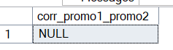
- Which product clusters (from product hierarchy) show consistent growth or decline?
with cluster_sales as(
select
dp.cluster_id as product_cluster,
sum(fs.sales) as total_sales,
sum(fs.revenue) as revenue,
dd.year as year
from fact_sales fs
join dim_product dp on fs.product_id = dp.product_id
join dim_date dd on fs.date = dd.date
group by dp.cluster_id, dd.year, fs.sales
)
select
product_cluster,
year,
total_sales,
lag(total_sales,1) over (partition by product_cluster order by year) as prev_year_sales,
total_sales - lag(total_sales,1) over (partition by product_cluster order by year) as YoY_change,
ROUND(
(total_sales - lag(total_sales,1) over (partition by product_cluster order by year))
/ nullif(lag(total_sales,1) over (partition by product_cluster order by year),0) * 100,
2
) as YoY_percent_change
from cluster_sales
order by year

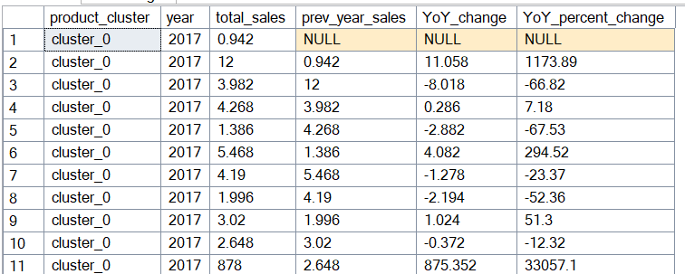

- How does stock level relate to sales performance (overstocking or stockouts)?
In this query I decided to see the product cluster performance with stock and stock turnover to get more useful information
SELECT
dp.cluster_id as product_cluster,
AVG(fs.stock) AS avg_stock,
AVG(fs.sales) AS avg_sales,
AVG(fs.stock_turnover) AS turnover_ratio
FROM fact_sales fs
join dim_product dp on fs.product_id = dp.product_id
GROUP BY dp.cluster_id
ORDER BY turnover_ratio DESC;

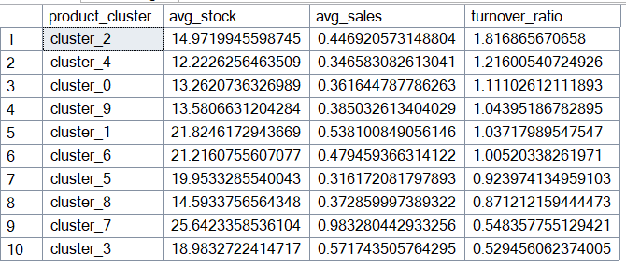

- Which cities or store types (storetype_id) drive the most revenue per square meter (store_size)?
I chose to get the top 10 stores that generate revenue per sqm
SELECT TOP 10
ds.store_id,
ds.store_size,
SUM(fs.revenue) / ds.store_size AS revenue_per_sqm
FROM fact_sales fs
JOIN dim_store ds ON fs.store_id = ds.store_id
GROUP BY ds.store_id, ds.store_size
ORDER BY revenue_per_sqm DESC;
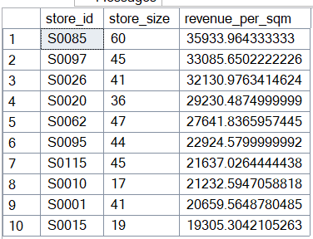
- What’s the sales-to-stock ratio per product category or cluster?
I chose to use hierarchy3 instead of cluster id to show better granuality and performance
WITH cluster_summary AS (
SELECT
dp.hierarchy3_id,
SUM(fs.stock) AS total_stock,
SUM(fs.sales) AS total_sales,
COUNT(*) AS product_count
FROM fact_sales fs
JOIN dim_product dp ON fs.product_id = dp.product_id
GROUP BY dp.hierarchy3_id
),
performance_metrics AS (
SELECT
hierarchy3_id,
total_stock,
total_sales,
product_count,
CASE
WHEN total_stock = 0 THEN 'Out of Stock'
WHEN total_sales = 0 THEN 'Dead Stock'
ELSE CONCAT(
FORMAT((total_sales * 100.0) / total_stock, 'N2'),
'% turnover'
)
END AS turnover_rate,
CASE
WHEN total_stock = 0 THEN 'Critical - Restock Needed'
WHEN total_sales = 0 THEN 'Action Required - Promote or Clear'
WHEN total_sales * 1.0 / NULLIF(total_stock, 0) > 0.8 THEN 'High Performance'
WHEN total_sales * 1.0 / NULLIF(total_stock, 0) < 0.2 THEN 'Low Performance'
ELSE 'Stable'
END AS performance_tier,
ROUND(total_sales * 1.0 / NULLIF(total_stock, 0), 3) AS sales_to_stock_ratio
FROM cluster_summary
)
SELECT
hierarchy3_id,
total_stock,
total_sales,
product_count,
turnover_rate,
performance_tier,
sales_to_stock_ratio
FROM performance_metrics
ORDER BY sales_to_stock_ratio DESC
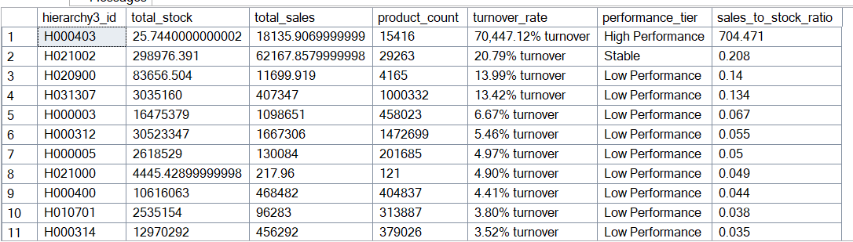
- How do promotions differ in effectiveness across cities or clusters?
SELECT
ds.city_id,
fs.promo_type_1,
fs.promo_type_2,
AVG(fs.sales) AS avg_sales
FROM fact_sales fs
JOIN dim_store ds ON fs.store_id = ds.store_id
WHERE fs.promo_type_1 IS NOT NULL OR fs.promo_type_2 IS NOT NULL
GROUP BY ds.city_id, fs.promo_type_1, promo_type_2
ORDER BY ds.city_id, avg_sales DESC;
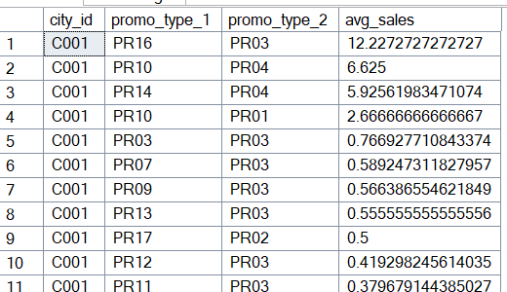

- What are the most profitable product lines by hierarchy level (e.g., hierarchy3_id or hierarchy4_id)?
We assumed a fixed profit margin of 30%
SELECT
dp.hierarchy1_id,
dp.hierarchy2_id,
dp.hierarchy3_id,
SUM(fs.revenue) AS total_revenue,
(SUM(fs.revenue) * 0.3) as estimated_profit
from fact_sales fs
join dim_product dp on fs.product_id = dp.product_id
group by dp.hierarchy1_id, dp.hierarchy2_id, dp.hierarchy3_id
order by estimated_profit desc
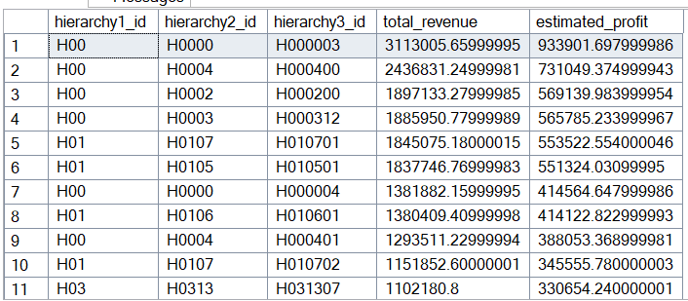

Data transformation on power bi
- In dim_product table:
- Missing cluster id was replaced by a fall-back cluster id cluster_m, 50 records had missing cluster.

